Cylindrical Solids of Revolution

Definition
# Source: AI Source: Provided by: [Data Path: Persons Table -> ID Column: 1, Name_En Column: Motasem Essam] -> From: [ChatGPT] on [7/25/2026]
Cylindrical Solids of Revolution are three-dimensional solids generated by rotating a rectangular plane region through a complete revolution of ${360}^{∘}$ around a straight axis parallel to one of the rectangle's sides.
The rotation produces a solid with circular cross-sections perpendicular to the axis and a cylindrical outer surface.
Depending on the position of the axis relative to the rectangle, the generated solid can be a solid right circular cylinder or a hollow cylindrical solid (annular cylinder).

Geometric Representation
# Source: AI Source: Provided by: [Data Path: Persons Table -> ID Column: 1, Name_En Column: Motasem Essam] -> From: [ChatGPT] on [7/25/2026]
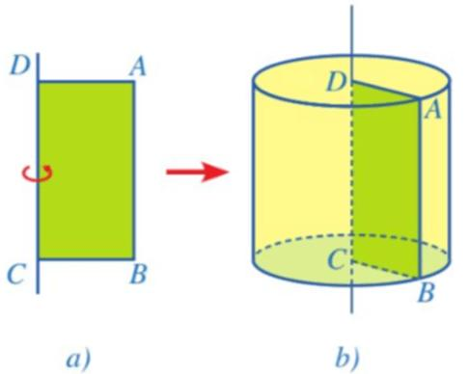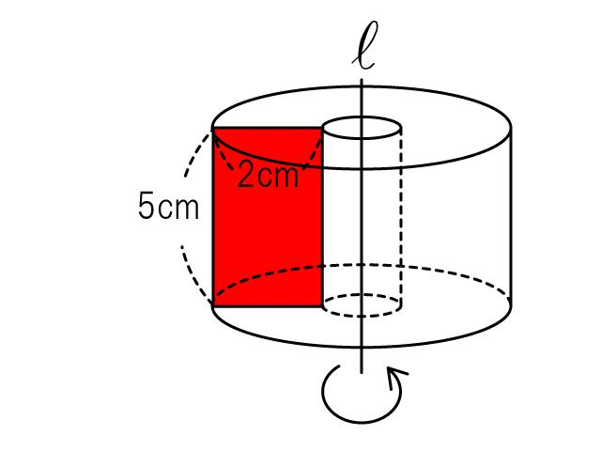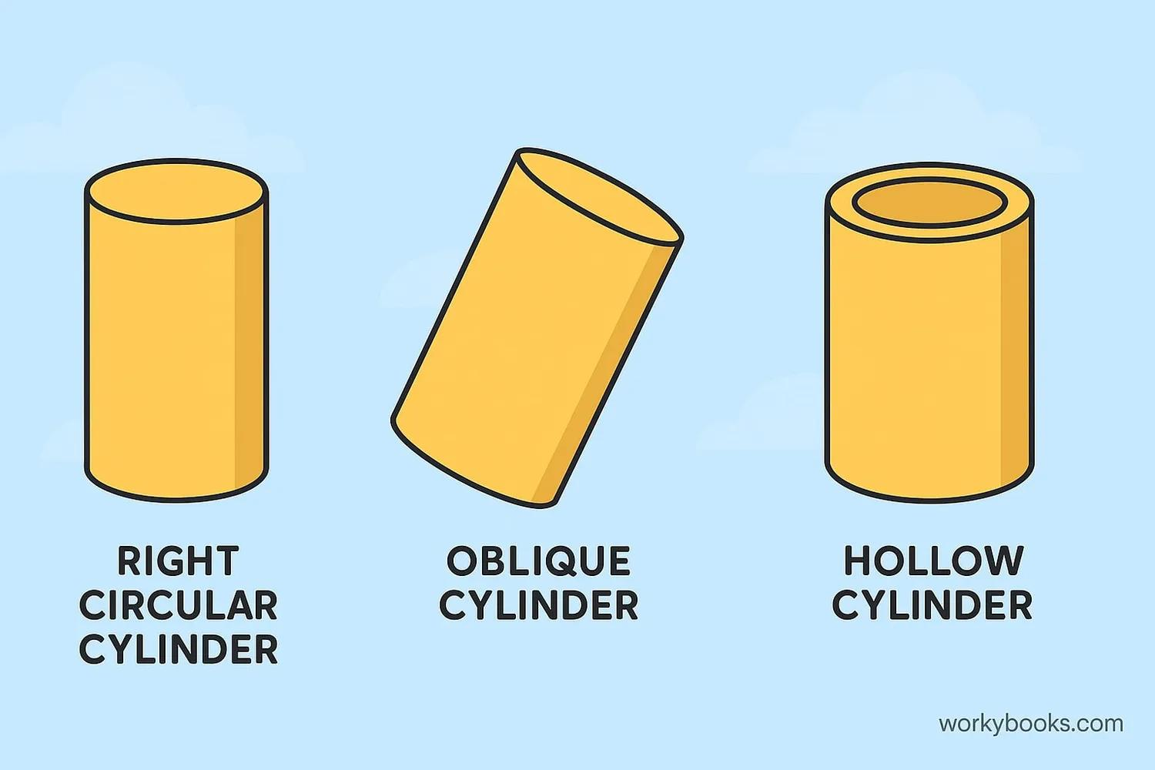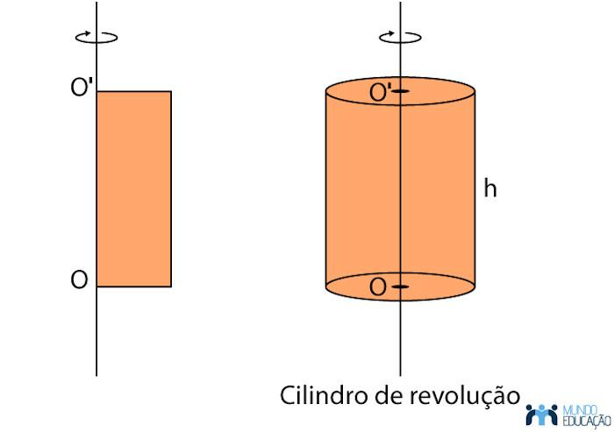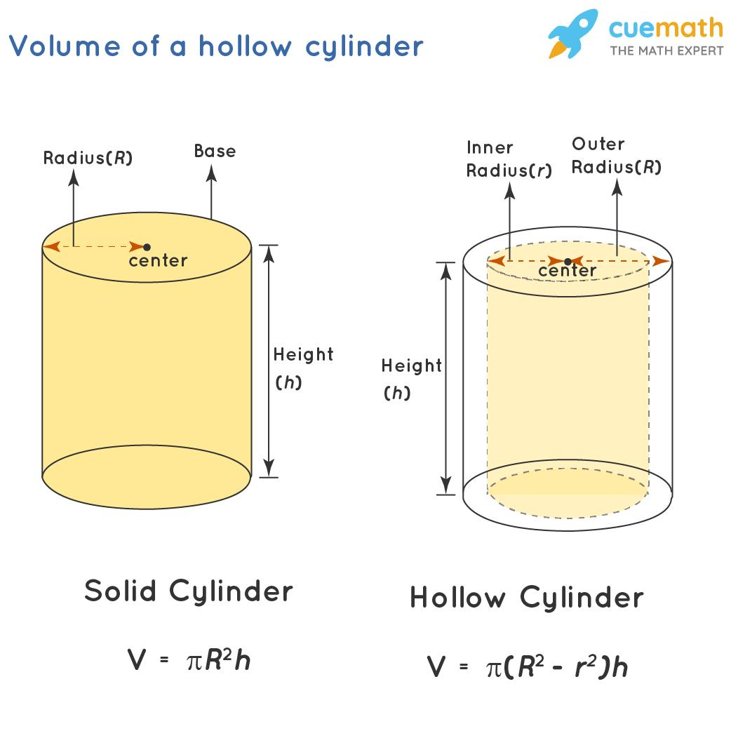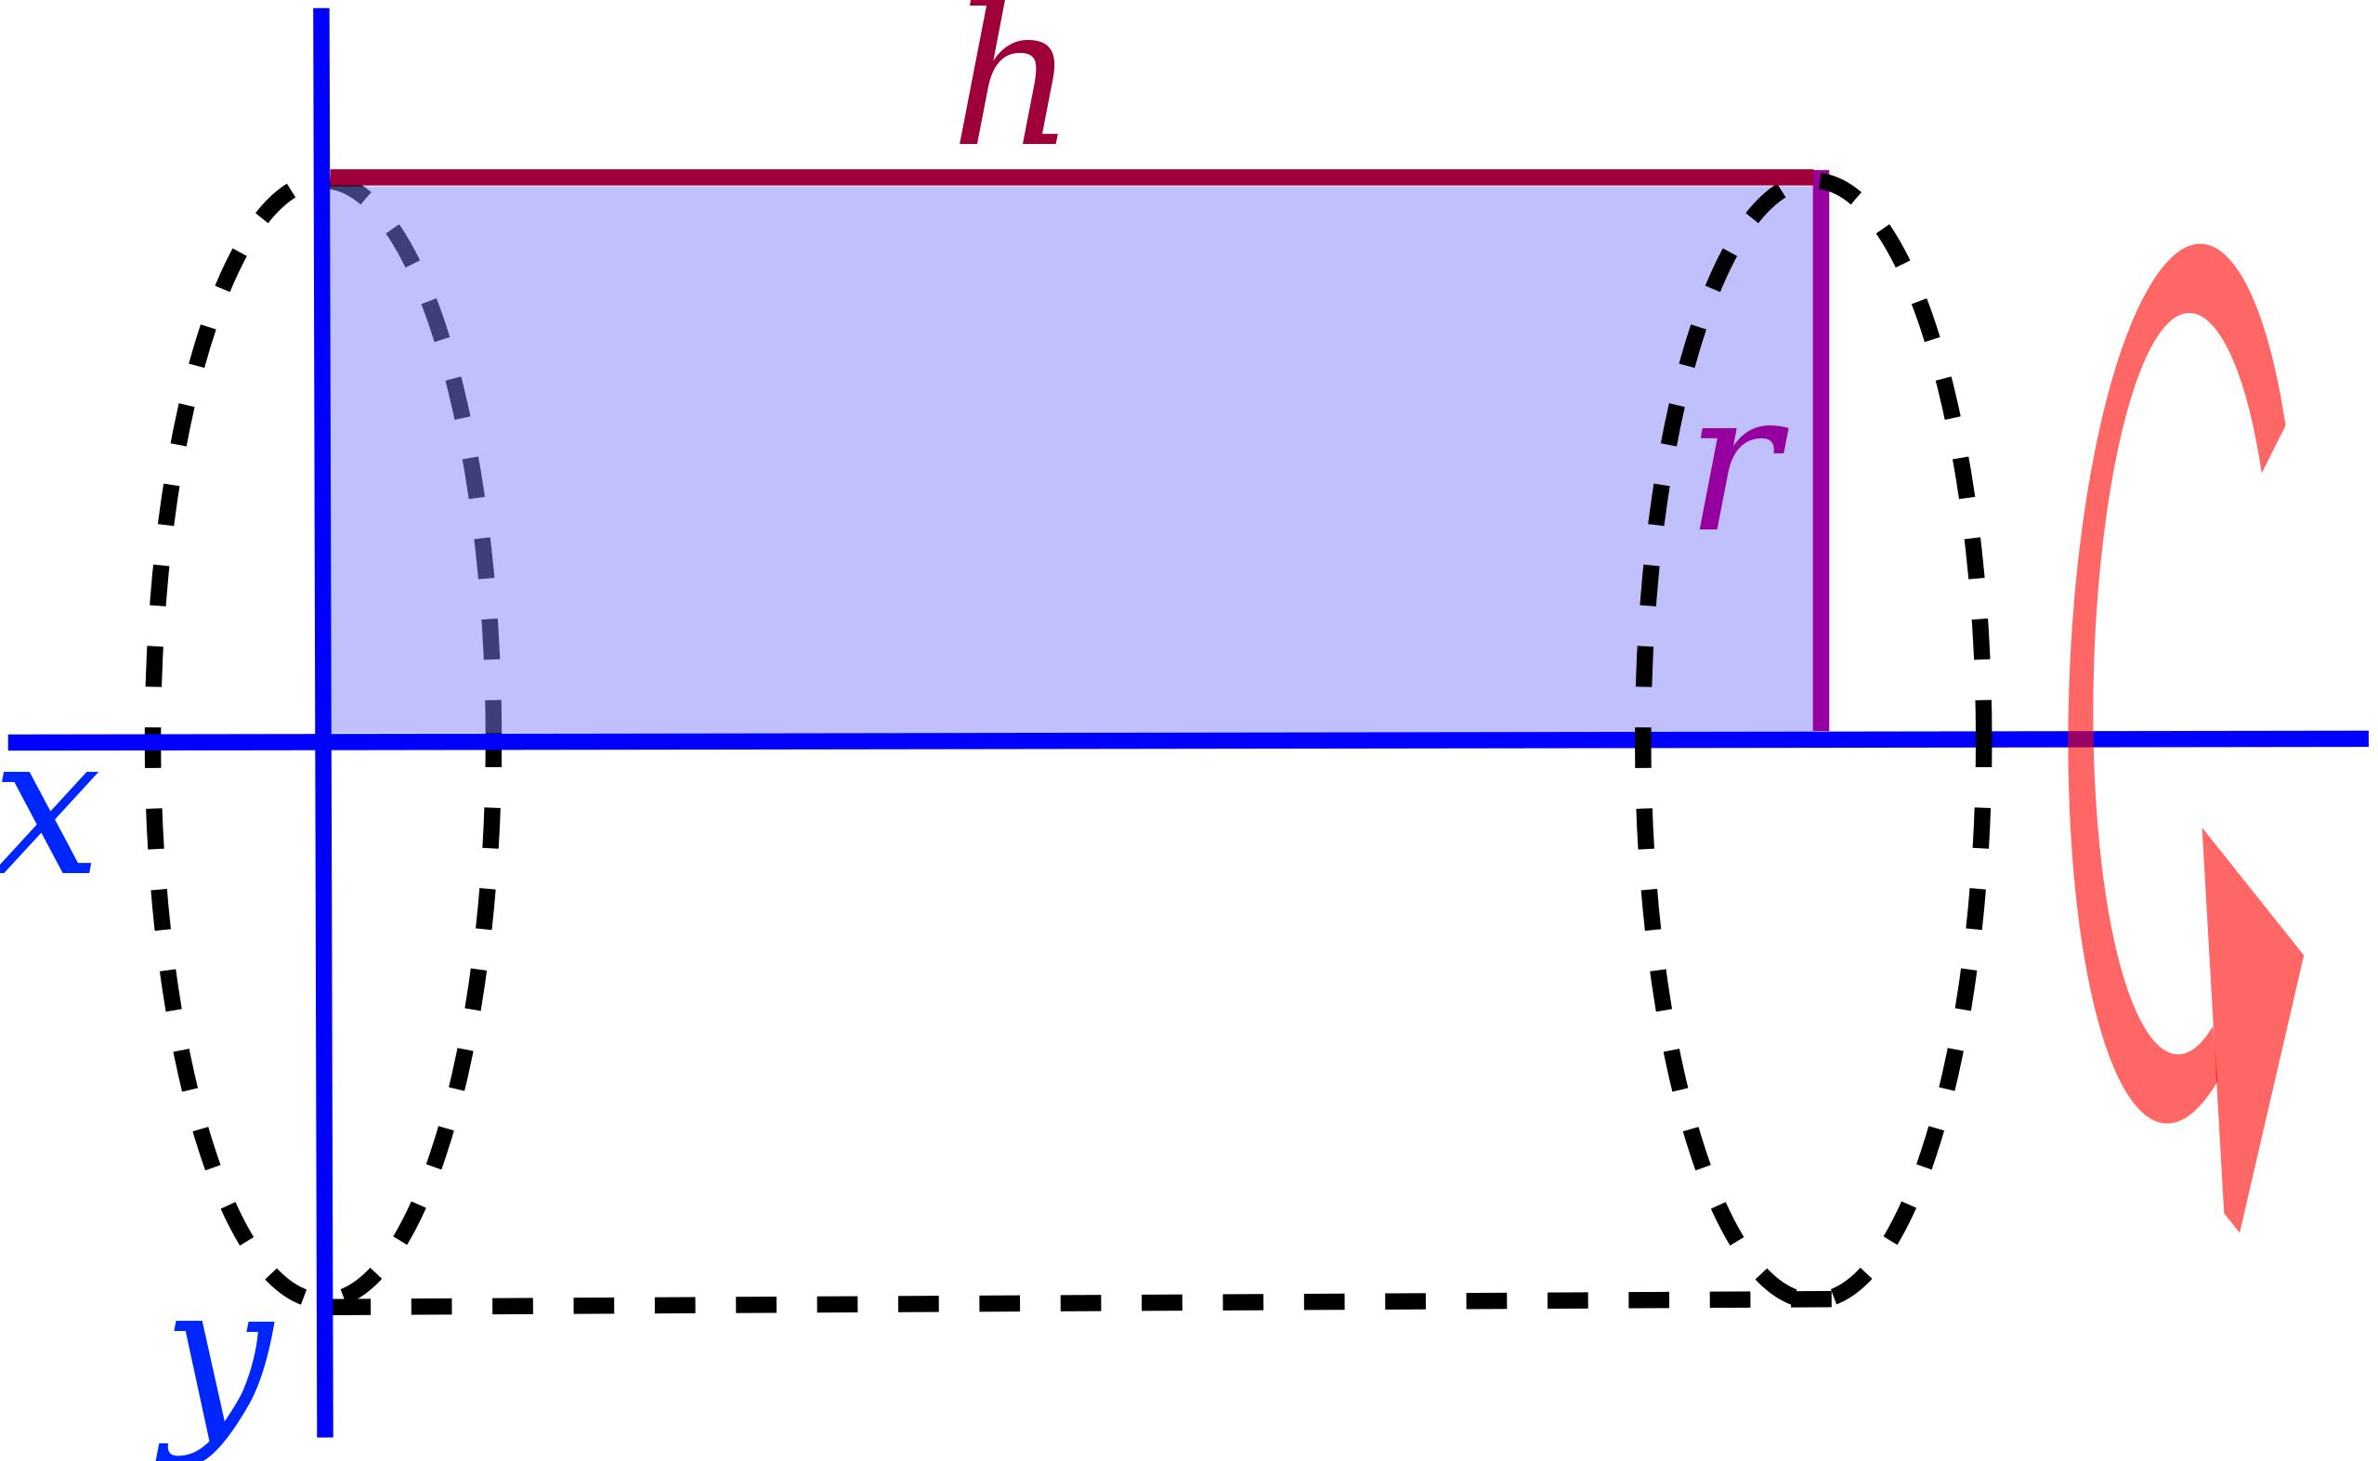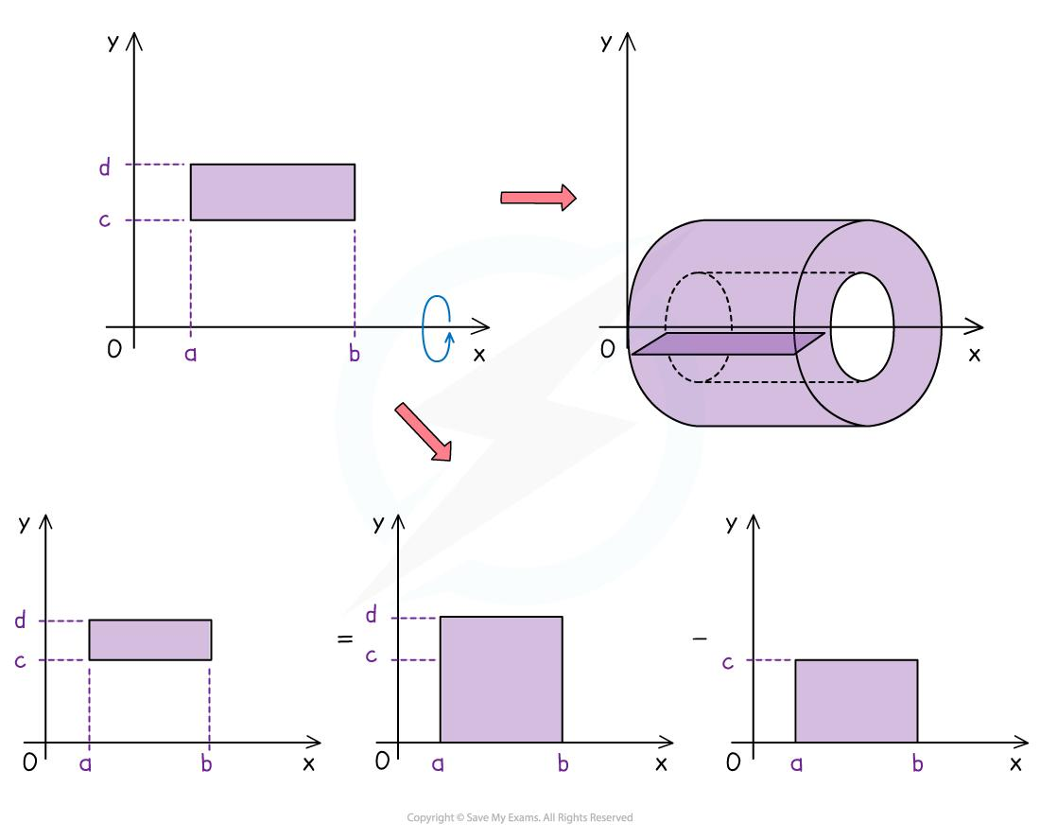
The generating rectangle determines the dimensions of the cylindrical solid:
- The rectangle's side parallel to the axis determines the cylinder's height.
- The perpendicular distance from the axis to the outer edge determines the outer radius.
- If the region does not reach the axis, the rotation creates an inner cylindrical opening.
- If the region reaches the axis, the generated solid has no central opening.

Geometric Structure
# Source: AI Source: Provided by: [Data Path: Persons Table -> ID Column: 1, Name_En Column: Motasem Essam] -> From: [ChatGPT] on [7/25/2026]
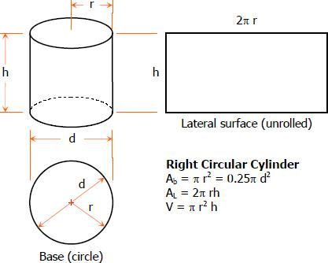
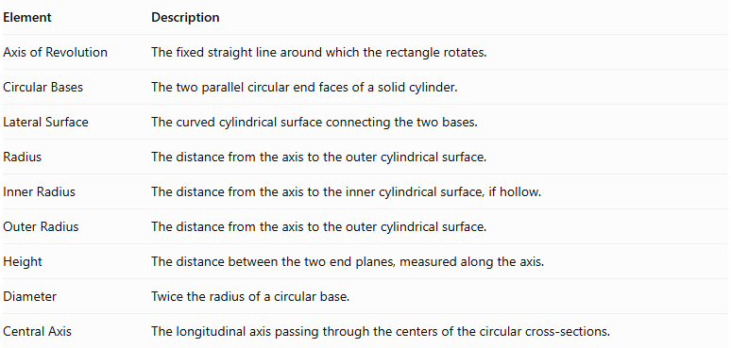
Element | Description
Axis of Revolution | The fixed straight line around which the rectangle rotates.
Circular Bases | The two parallel circular end faces of a solid cylinder.
Lateral Surface | The curved cylindrical surface connecting the two bases.
Radius | The distance from the axis to the outer cylindrical surface.
Inner Radius | The distance from the axis to the inner cylindrical surface, if hollow.
Outer Radius | The distance from the axis to the outer cylindrical surface.
Height | The distance between the two end planes, measured along the axis.
Diameter | Twice the radius of a circular base.
Central Axis | The longitudinal axis passing through the centers of the circular cross-sections.

Types of Cylindrical Solids of Revolution

Solid Right Circular Cylinder
# Source: AI Source: Provided by: [Data Path: Persons Table -> ID Column: 1, Name_En Column: Motasem Essam] -> From: [ChatGPT] on [7/25/2026]
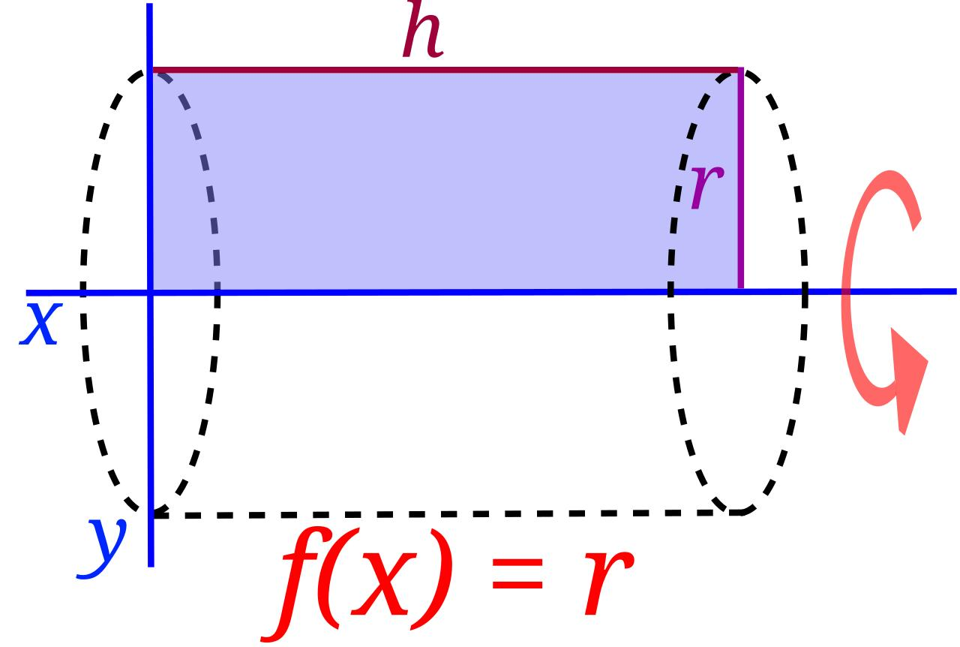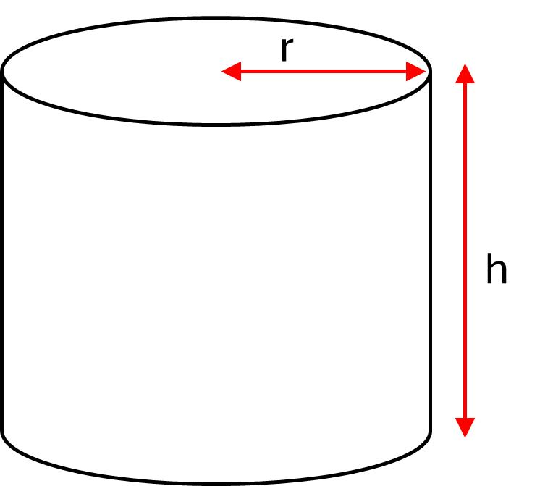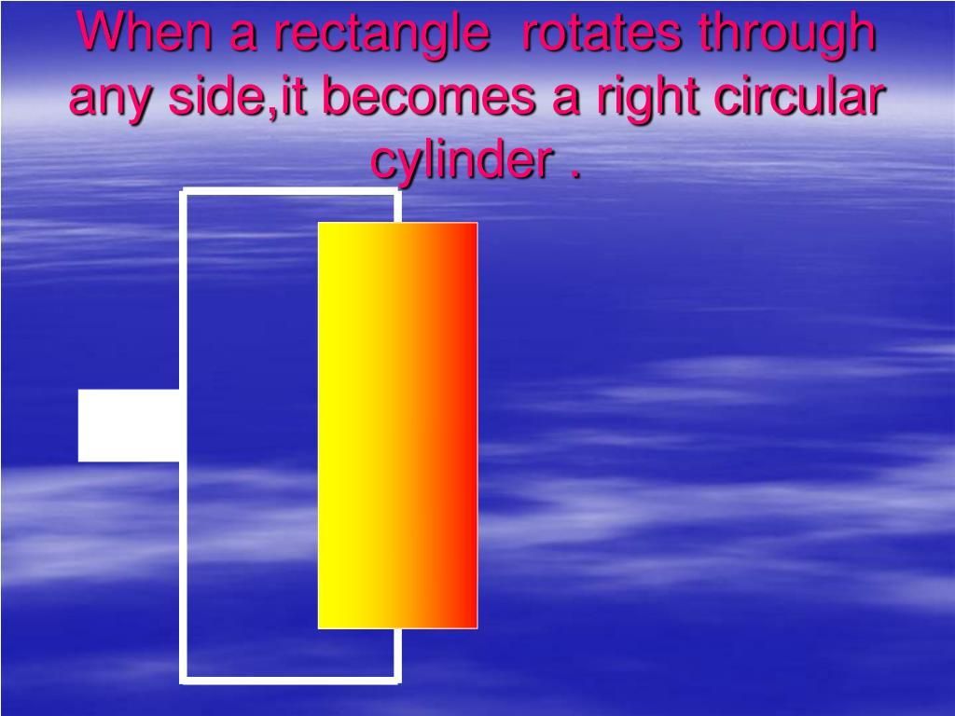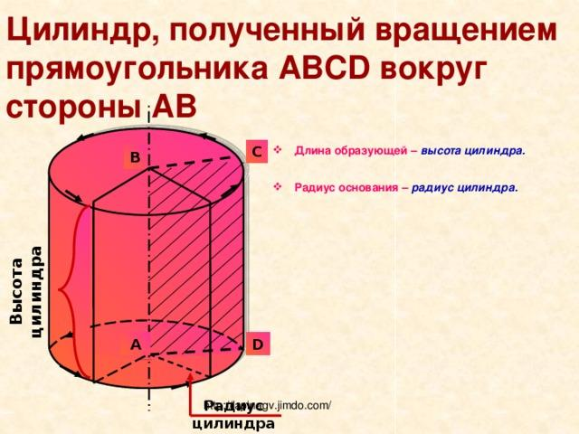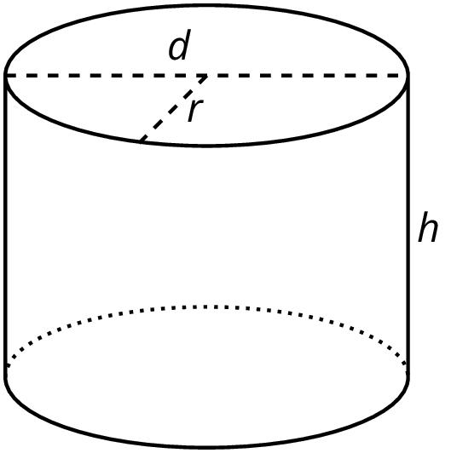
A Solid Right Circular Cylinder is generated when a rectangular region rotates around one of its sides.
The side used as the axis of revolution becomes the cylinder's central axis, while the opposite side traces the outer cylindrical surface.
Geometric characteristics:
- Two parallel circular bases.
- One curved lateral surface.
- A constant circular cross-section along its height.
- No central opening.

Hollow Cylindrical Solid
# Source: AI Source: Provided by: [Data Path: Persons Table -> ID Column: 1, Name_En Column: Motasem Essam] -> From: [ChatGPT] on [7/25/2026]
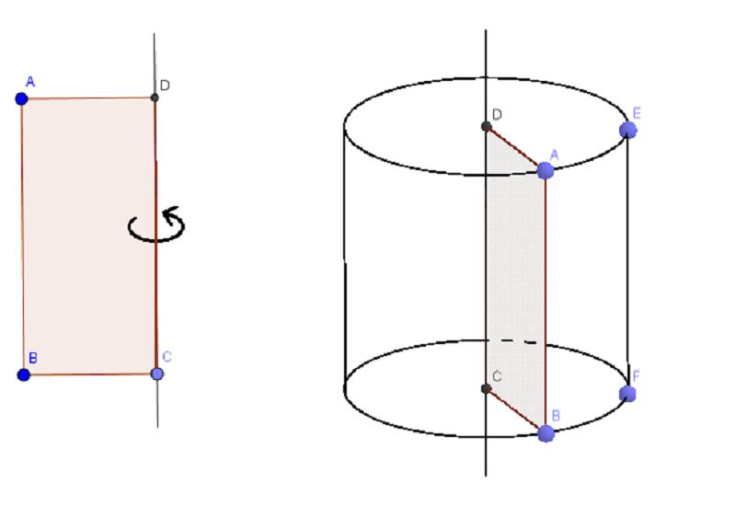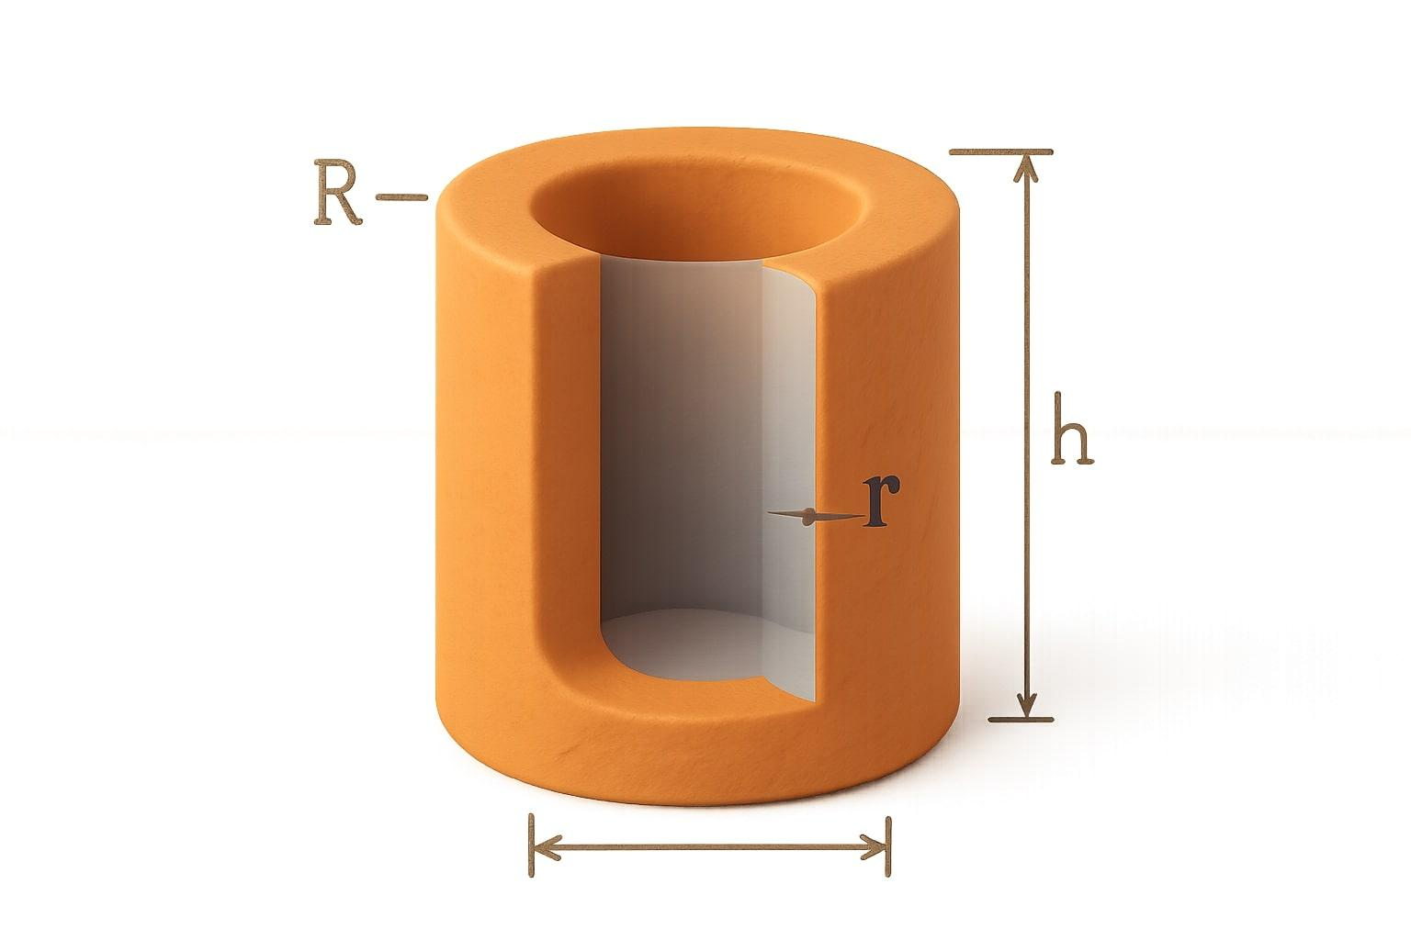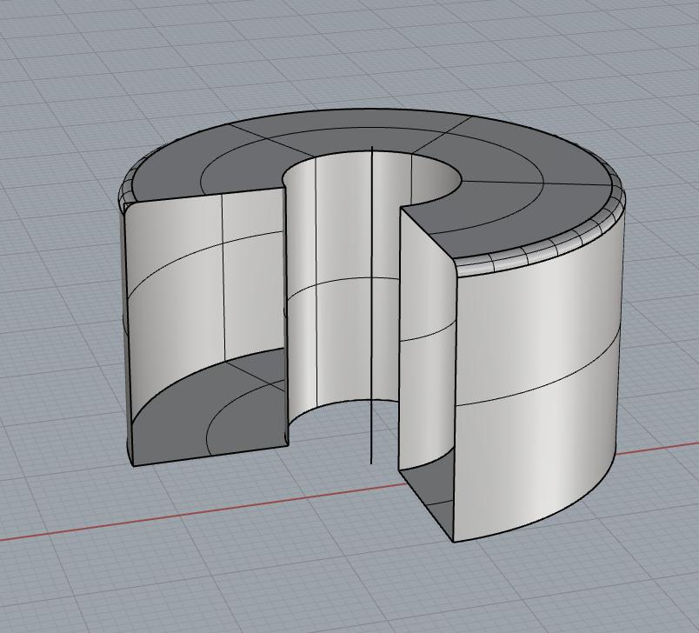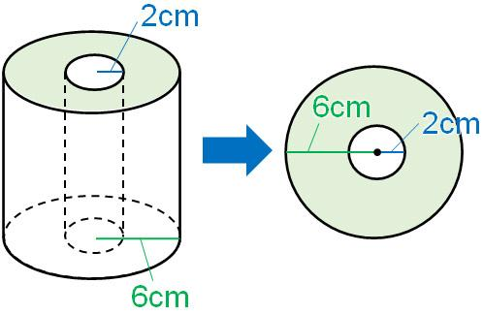
A Hollow Cylindrical Solid is generated when a rectangular region rotates around an external axis parallel to one of its sides, without touching the axis.
The rectangle sweeps out the material between two concentric cylindrical surfaces.
Geometric characteristics:
- One outer cylindrical surface.
- One inner cylindrical surface.
- Two annular end faces.
- A constant annular cross-section along its height.
- A central cylindrical opening.

Thick-Walled Cylindrical Solid
# Source: AI Source: Provided by: [Data Path: Persons Table -> ID Column: 1, Name_En Column: Motasem Essam] -> From: [ChatGPT] on [7/25/2026]
A Thick-Walled Cylindrical Solid is a hollow cylindrical solid with a substantial radial distance between its inner and outer surfaces.
It is geometrically the same general type as a hollow cylindrical solid; thick-walled describes its wall thickness rather than a separate method of generation.

Thin-Walled Cylindrical Solid
# Source: AI Source: Provided by: [Data Path: Persons Table -> ID Column: 1, Name_En Column: Motasem Essam] -> From: [ChatGPT] on [7/25/2026]
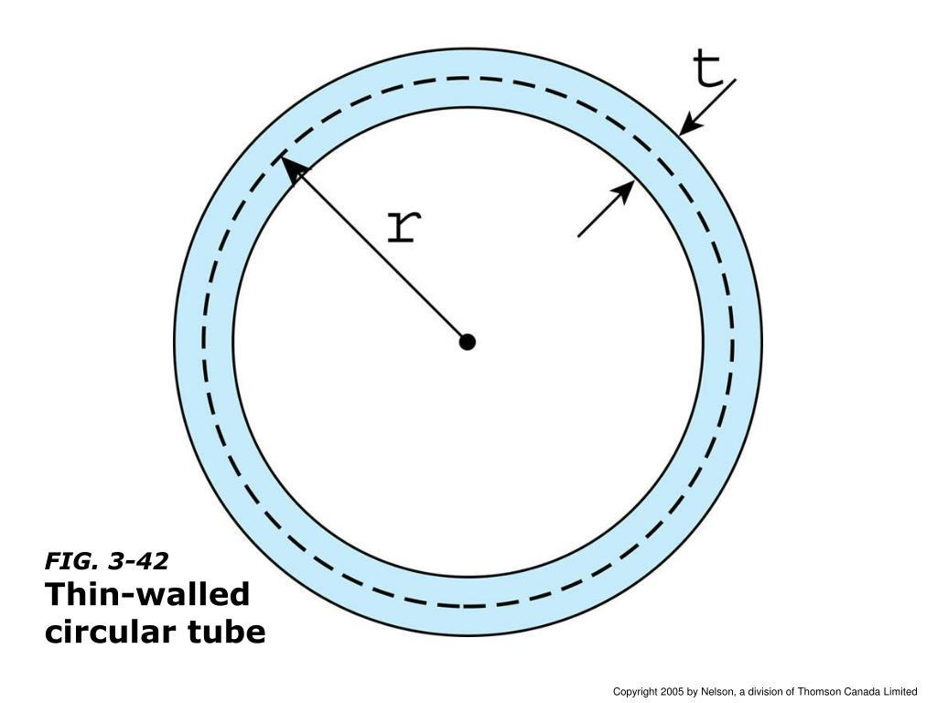
A Thin-Walled Cylindrical Solid is a hollow cylindrical solid whose wall thickness is small compared with its outer radius.
It is commonly used to model tubes, pipes, and cylindrical shells.
Important distinction: A thin-walled cylindrical solid still has a nonzero wall thickness. An ideal mathematical cylindrical surface has no thickness and is not itself a solid.

Mathematical Representation

Solid Right Circular Cylinder
# Source: AI Source: Provided by: [Data Path: Persons Table -> ID Column: 1, Name_En Column: Motasem Essam] -> From: [ChatGPT] on [7/25/2026]
Let:
- $r$ = radius.
- $h$ = height.
- $x$ = distance from the axis of revolution to the outer side of the rectangle.
The volume is:
$$\boxed{V=πr^{2}h}$$
The base area is:
$$A_{b}=πr^{2}$$
The circumference of the base is:
$$C=2πr$$
The lateral surface area is:
$$A_{L}=2πrh$$
The total surface area is:
$$\boxed{A_{T}=2πr(r+h)}$$

Hollow Cylindrical Solid
# Source: AI Source: Provided by: [Data Path: Persons Table -> ID Column: 1, Name_En Column: Motasem Essam] -> From: [ChatGPT] on [7/25/2026]
Let:
- $R$ = outer radius.
- $r$ = inner radius.
- $h$ = height.
- $t=R-r$ = wall thickness.
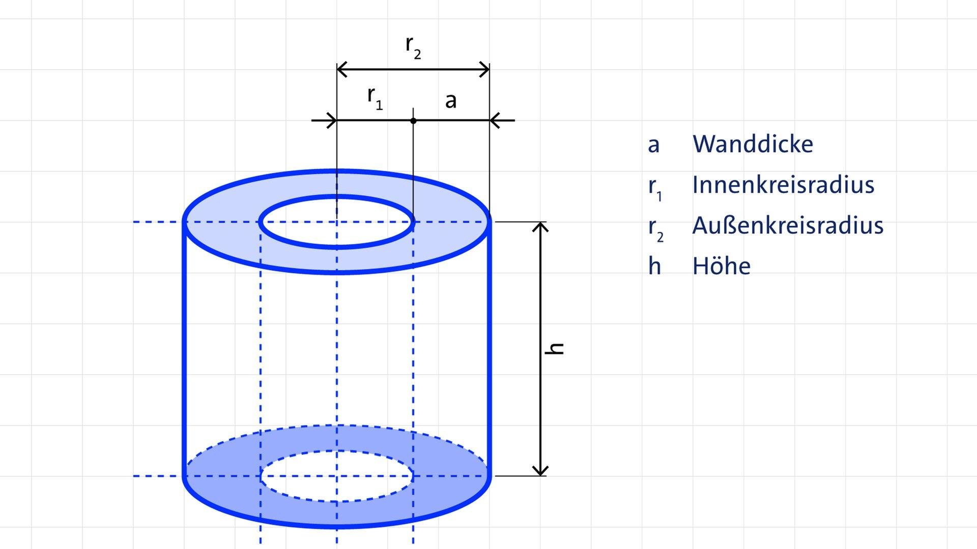
The volume is:
$$\boxed{V=πh(R^{2}-r^{2})}$$
The annular base area is:
$$A_{b}=π(R^{2}-r^{2})$$
The outer lateral surface area is:
$$A_{Lo}=2πRh$$
The inner lateral surface area is:
$$A_{Li}=2πrh$$
The total surface area, including both annular ends, is:
$$\boxed{A_{T}=2πh(R+r)+2π(R^{2}-r^{2})}$$
The wall thickness is:
$$\boxed{t=R-r}$$

Mathematical Properties
# Source: AI Source: Provided by: [Data Path: Persons Table -> ID Column: 1, Name_En Column: Motasem Essam] -> From: [ChatGPT] on [7/25/2026]
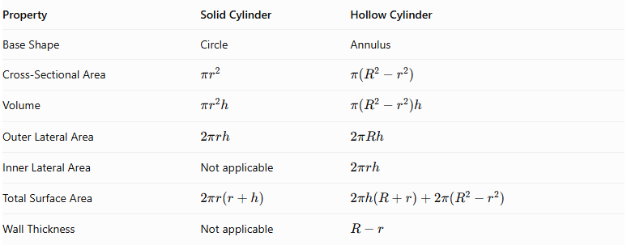
Property | Solid Cylinder | Hollow Cylinder
Base Shape | Circle | Annulus
Cross-Sectional Area | $$πr^{2}$$ | $$π(R^{2}-r^{2})$$
Volume | $$πr^{2}h$$ | $$π(R^{2}-r^{2})h$$
Outer Lateral Area | $$2πrh$$ | $$2πRh$$
Inner Lateral Area | Not applicable | $$2πrh$$
Total Surface Area | $$2πr(r+h)$$ | $$2πh(R+r)+2π(R^{2}-r^{2})$$
Wall Thickness | Not applicable | $$R-r$$

Applications
# Source: AI Source: Provided by: [Data Path: Persons Table -> ID Column: 1, Name_En Column: Motasem Essam] -> From: [ChatGPT] on [7/25/2026]
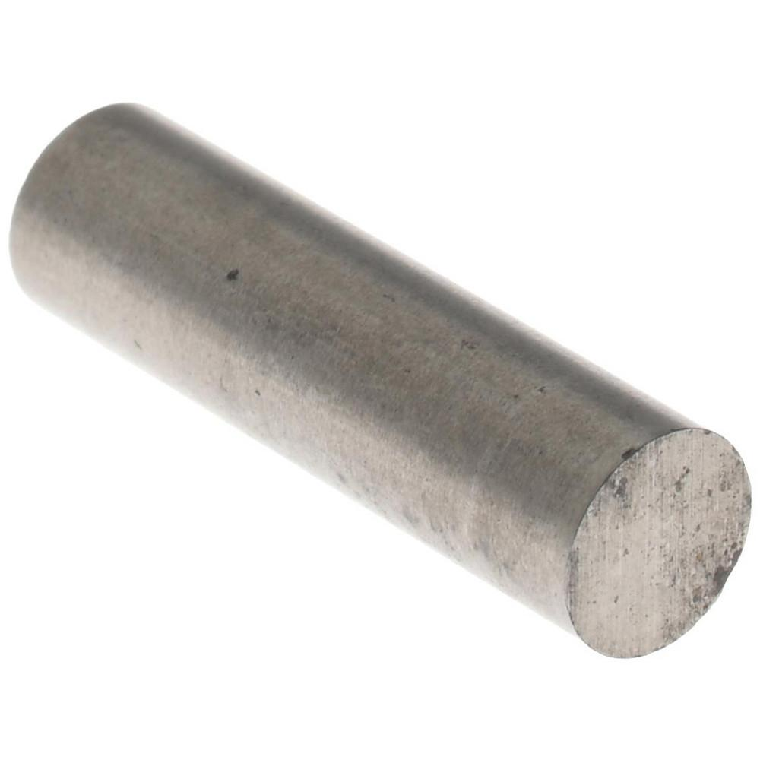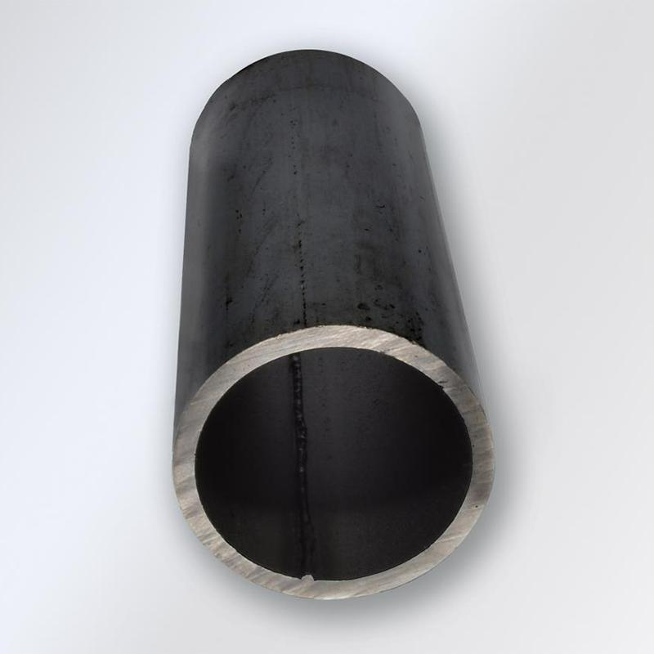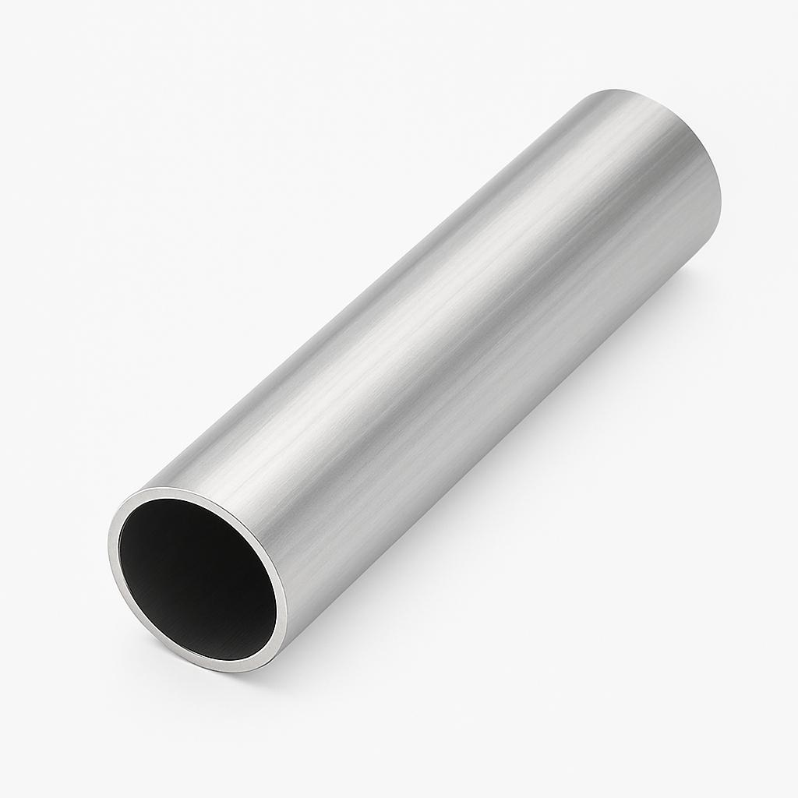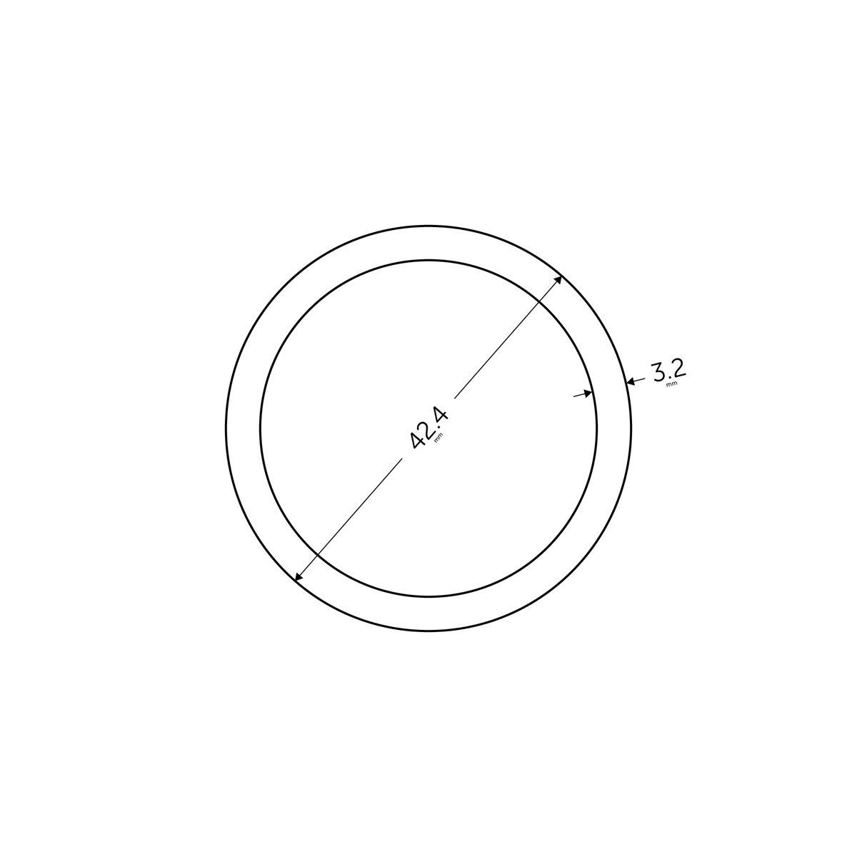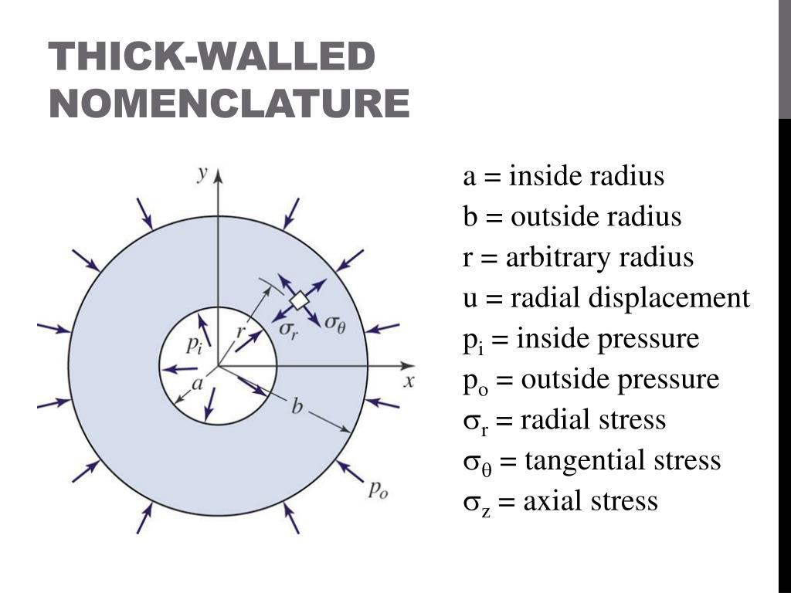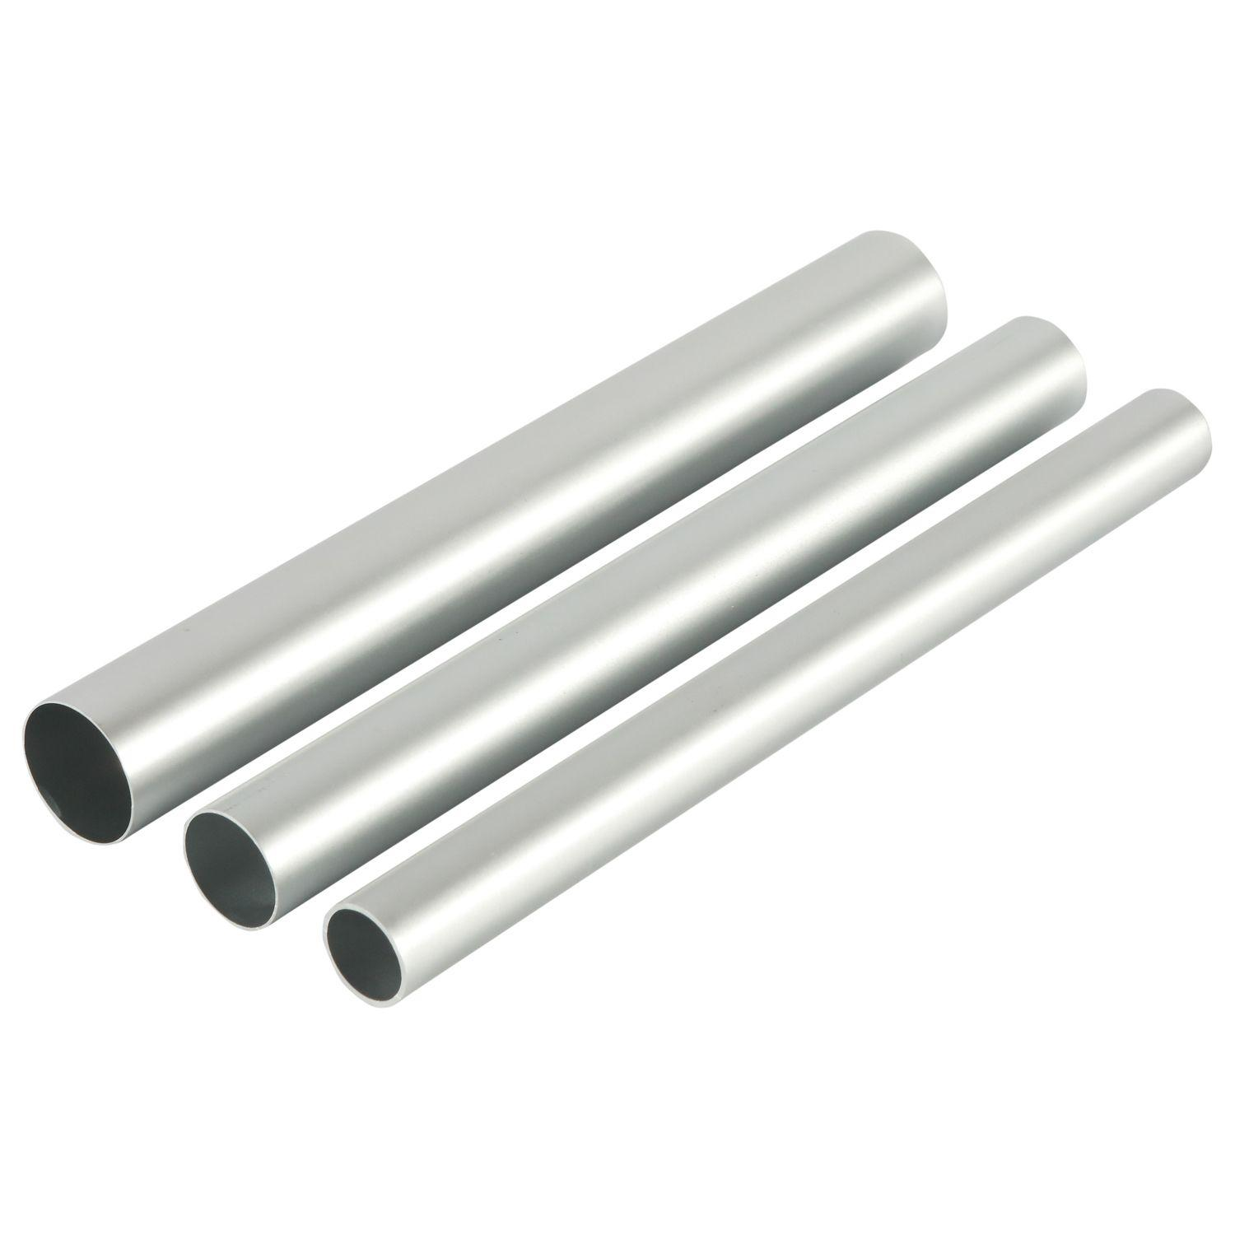
Cylindrical solids of revolution are used in:
- Mechanical Engineering: Shafts, rollers, pistons, and cylindrical machine components.
- Construction: Concrete columns, cylindrical pillars, and structural supports.
- Plumbing: Pipes, water conduits, and cylindrical connectors.
- Manufacturing: Metal rods, tubes, containers, and turned components.
- Industrial Engineering: Pressure vessels, storage tanks, and cylindrical housings.
- Transportation: Axles, rollers, and rotating mechanical components.

Comparison Between Cylindrical Solids
# Source: AI Source: Provided by: [Data Path: Persons Table -> ID Column: 1, Name_En Column: Motasem Essam] -> From: [ChatGPT] on [7/25/2026]
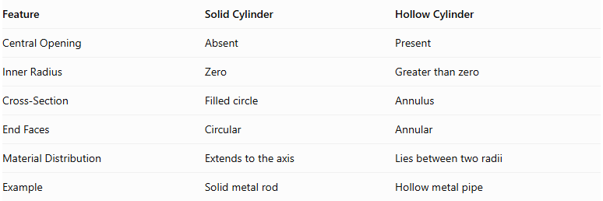
Feature | Solid Cylinder | Hollow Cylinder
Central Opening | Absent | Present
Inner Radius | Zero | Greater than zero
Cross-Section | Filled circle | Annulus
End Faces | Circular | Annular
Material Distribution | Extends to the axis | Lies between two radii
Example | Solid metal rod | Hollow metal pipe

Main Classification
# Source: AI Source: Provided by: [Data Path: Persons Table -> ID Column: 1, Name_En Column: Motasem Essam] -> From: [ChatGPT] on [7/25/2026]
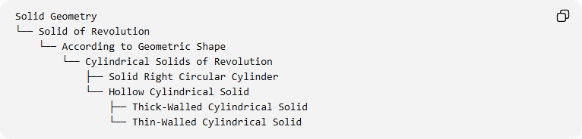
Solid Geometry
└── Solid of Revolution
└── According to Geometric Shape
└── Cylindrical Solids of Revolution
├── Solid Right Circular Cylinder
└── Hollow Cylindrical Solid
├── Thick-Walled Cylindrical Solid
└── Thin-Walled Cylindrical Solid

Key Points
# Source: AI Source: Provided by: [Data Path: Persons Table -> ID Column: 1, Name_En Column: Motasem Essam] -> From: [ChatGPT] on [7/25/2026]
- Cylindrical solids of revolution are generated by rotating rectangular regions around suitable parallel axes.
- A rectangle rotated around one of its sides generates a solid right circular cylinder.
- A rectangle rotated around an external parallel axis can generate a hollow cylindrical solid.
- A solid cylinder has a circular cross-section.
- A hollow cylinder has an annular cross-section.
- Wall thickness is the difference between the outer and inner radii.
- Both types have cylindrical lateral surfaces and constant cross-sections along their axes.

Conclusion
# Source: AI Source: Provided by: [Data Path: Persons Table -> ID Column: 1, Name_En Column: Motasem Essam] -> From: [ChatGPT] on [7/25/2026]
Cylindrical Solids of Revolution are solids generated by rotating rectangular regions around suitable axes. Their principal forms are solid right circular cylinders and hollow cylindrical solids. They are fundamental examples of solids of revolution and are widely used in geometry, engineering, construction, and manufacturing.

